**Shravani**

**Percentage**

Decimal denominator = 300; // Denominator value

Decimal maths = 70;

Decimal physics =54;

Decimal chemistry = 88;

Decimal numerator = maths+physics+chemistry;

Decimal percentage = (numerator / denominator) * 100;

// Output the percentage value

System.debug('Percentage: ' + percentage);



**Apex class**

public class PercentageCalculatorController {

public Decimal subject1 { get; set; }

public Decimal subject2 { get; set; }

public Decimal subject3 { get; set; }

public Decimal percentage { get; set; }

public Boolean showResult { get; set; }

public void calculatePercentage() {

showResult = true;

Decimal totalMarks = subject1 + subject2 + subject3;

percentage = (totalMarks / 300) * 100;

}

}

**Visualforce**

<apex:page controller="PercentageCalculatorController">

<apex:form>

<apex:pageBlock title="Percentage Calculator">

<apex:pageBlockSection>

<apex:inputText value="{!subject1}" label="Subject 1"/>

<apex:inputText value="{!subject2}" label="Subject 2"/>

<apex:inputText value="{!subject3}" label="Subject 3"/>

<apex:commandButton value="Calculate" action="{!calculatePercentage}" rerender="resultPanel"/>

</apex:pageBlockSection>

</apex:pageBlock>

<apex:outputPanel id="resultPanel">

<apex:outputText value="Percentage: {!percentage}" rendered="{!showResult}"/>

</apex:outputPanel>

</apex:form>

</apex:page>

**Calculator**

Decimal num1 = 10;

Decimal num2 = 5;

Decimal sum = num1+num2;

System.debug('Sum: ' + sum);

Decimal difference = num1-num2;

System.debug('Difference: ' + difference);

Decimal multiplication = num1*num2;

System.debug('Product: ' + multiplication);

Decimal division = num1/num2;

System.debug('Quotient: ' + division);

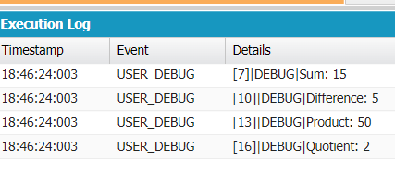

**Apex class**

public class CalculatorController {

public Decimal operand1 { get; set; }

public Decimal operand2 { get; set; }

public String operator { get; set; }

public Decimal result { get; set; }

public Boolean showResult { get; set; }

public List<SelectOption> getOperators() {

List<SelectOption> options = new List<SelectOption>();

options.add(new SelectOption('+', 'Add'));

options.add(new SelectOption('-', 'Subtract'));

options.add(new SelectOption('*', 'Multiply'));

options.add(new SelectOption('/', 'Divide'));

return options;

}

public void calculate() {

showResult = true;

if (operator == '+') {

result = operand1 + operand2;

} else if (operator == '-') {

result = operand1 - operand2;

} else if (operator == '*') {

result = operand1 * operand2;

} else if (operator == '/') {

if (operand2 != 0) {

result = operand1 / operand2;

} else {

ApexPages.addMessage(new ApexPages.Message(ApexPages.Severity.ERROR, 'Division by zero is not allowed.'));

showResult = false;

}

}

}

}

**Visualforce page**

<apex:page controller="CalculatorController">

<apex:form>

<apex:pageBlock title="Calculator">

<apex:pageBlockSection>

<apex:inputText value="{!operand1}" label="Operand 1"/>

<apex:inputText value="{!operand2}" label="Operand 2"/>

<apex:selectList value="{!operator}" size="1">

<apex:selectOptions value="{!operators}"/>

</apex:selectList>

<apex:commandButton value="Calculate" action="{!calculate}" rerender="resultPanel"/>

</apex:pageBlockSection>

</apex:pageBlock>

<apex:outputPanel id="resultPanel">

<apex:outputText value="Result: {!result}" rendered="{!showResult}"/>

</apex:outputPanel>

</apex:form>

</apex:page>

**Celsius to Fahrenheit**

Decimal c = 27; // Celsius temperature to convert

System.debug('Fahrenheit: ' + ( c * 9/5) + 32);



**Apex class**

public class TemperatureConverterController {

public Decimal celsius { get; set; }

public Decimal fahrenheit { get; set; }

public Boolean showResult { get; set; }

public void convertTemperature() {

showResult = true;

fahrenheit = (celsius * 9 / 5) + 32;

}

}

**Visual page**

<apex:page controller="TemperatureConverterController">

<apex:form>

<apex:pageBlock title="Temperature Converter">

<apex:pageBlockSection>

<apex:inputText value="{!celsius}" label="Celsius"/>

<apex:commandButton value="Convert" action="{!convertTemperature}" rerender="resultPanel"/>

</apex:pageBlockSection>

</apex:pageBlock>

<apex:outputPanel id="resultPanel">

<apex:outputText value="Fahrenheit: {!fahrenheit}" rendered="{!showResult}"/>

</apex:outputPanel>

</apex:form>

</apex:page>

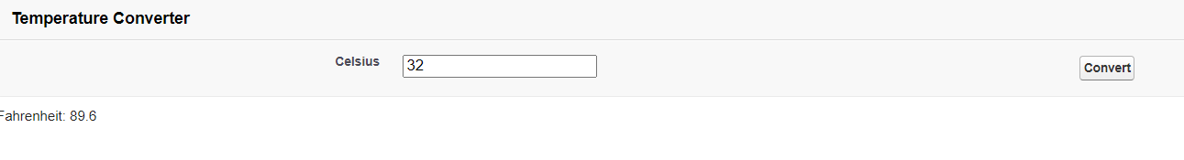

**Multiple choice**

**Visualforce page :**

<apex:page controller="MultipleChoiceQuestionController">

<apex:form>

<apex:pageBlock title="Multiple Choice Question">

<apex:pageBlockSection>

<apex:outputText value="Question: {!currentQuestion.questionText}" />

<apex:selectRadio value="{!selectedAnswer}">

<apex:selectOptions value="{!answerOptions}" />

</apex:selectRadio>

<apex:commandButton value="Submit" action="{!submitAnswer}" />

</apex:pageBlockSection>

</apex:pageBlock>

</apex:form>

</apex:page>

**Apex class :**

public class MultipleChoiceQuestionController {

public Question currentQuestion { get; set; }

public String selectedAnswer { get; set; }

public MultipleChoiceQuestionController() {

currentQuestion = new Question();

currentQuestion.questionText = 'What is the capital of France?';

currentQuestion.answerOptions = new List<SelectOption>();

currentQuestion.answerOptions.add(new SelectOption('A', 'Paris'));

currentQuestion.answerOptions.add(new SelectOption('B', 'London'));

currentQuestion.answerOptions.add(new SelectOption('C', 'Berlin'));

currentQuestion.answerOptions.add(new SelectOption('D', 'Madrid'));

}

public List<SelectOption> getAnswerOptions() {

return currentQuestion.answerOptions;

}

public PageReference submitAnswer() {

// Process the selected answer

// You can add your logic here to validate the selected answer or perform any other actions based on it.

// Redirect to another page or perform any necessary operations after submitting the answer.

// You can define the logic to determine the next question or action based on your requirements.

return null; // Return the PageReference for the next page or null if no redirection is needed.

}

public class Question {

public String questionText { get; set; }

public List<SelectOption> answerOptions { get; set; }

}

}

